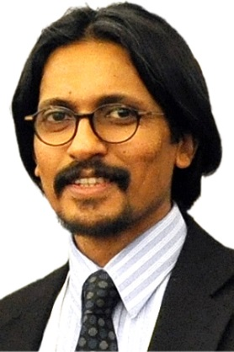
Raj NAIR
Raj is an internationally-known academic and clinician in Oral Medicine and Oral Oncology. He is Deputy Head of School (Research), Higher Degree Research (HDR) Convenor and Discipline Head of Oral Medicine, Oral Pathology and Human Diseases at Griffith University, Australia. He is Senior Oral Oncology Consultant, Haematology and Oncology (Cancer Services), Gold Coast University Hospital (GCUH), Queensland Health, Gold Coast, Australia. He is a full member of the Infection and Immunity Group (previously, Personalised Medicine in Cancer group) of Menzies Health Institute Queensland with over 100 publications, books and book chapter contributions.
He obtained his PhD in oral medicine and microbiology from the University of Hong Kong in 1996. He received his oral medicine/oncology clinical training as a fellow at Harvard and affiliated hospitals, USA and University of London, England, UK and recipient of research scholarship from Centre for Blood Disorders, Harvard Medical School. He was awarded membership in the special stream of Oral Medicine by the Royal Australasian College of Dental Surgeons (RACDS) in 2008.
His current research projects include but not limited to i) microbiome and cancer, ii) precision oral oncology and diagnositcs (microRNA studies); ii) photomedicine in cancer-therapy induced complications (international multi-centre); iii) oral mucositis and other complications amongst cancer patients (international multi-centre); and iv) gene polymorphisms in atypical orofacial pain disorders. He maintains external research collaborations with universities in the USA and Europe. He has presented a number of original research papers at international conferences and has given invited lectures world-wide since 1994.
Raj is the convenor of Griffith courses in the discipline of oral medicine, oral pathology and human diseases (internal medicine) which are designed and implemented by Raj. He contributes to education of specialist trainees and nurses at the GCUH and lectures at School of Pharmacy of Griffith University.
Raj holds membership in both professional and research bodies including International Association for Dental Research (IADR since 1994), American Academy of Oral Medicine (since 1998); International Society for Oral Oncology (ISOO) and Multinational Association of Supportive Care in Cancer (MASCC since 1999) and Harvard Club of Australia. He has been an invited consultant and member of international consensus bodies such as World Workshop in Oral Medicine, World Workshop in Oral Health and Diseases in AIDS and Oral Mucositis Group of MASCC/ISOO. He is also a Founding Member of the Oral Medicine Academy of Australasia.

Raj is President-Elect (future President) Oral Medicine and Pathology Group of International Association of Dental Research (IADR); Chair of Membership and Recruitment Committee and former Chair, Fellowship Committee of the IADR, ii) Vice President, Editor and Director Board Member of the International Society of Oral Oncology of Multinational Association of Supportive Care in Cancer (MASCC) (re-elected three terms) and iii) founding Board Member of International Group in Light in Oncology-Barcelona (iGLOB). He was the first Australian-Indian in the fifty year history of Royal Australasian College of Dental Surgeons (RACDS) to serve as an elected Director/Councillor (2012-2014). Raj is also a published author of fiction and established filmmaker.

SEMINAR TOPICS:

Epigenetics, microRNAs, Microbiome and Cancer - An Update on Precision Oral Oncology

Orofacial complications of cancer therapy – An update for clinicians

